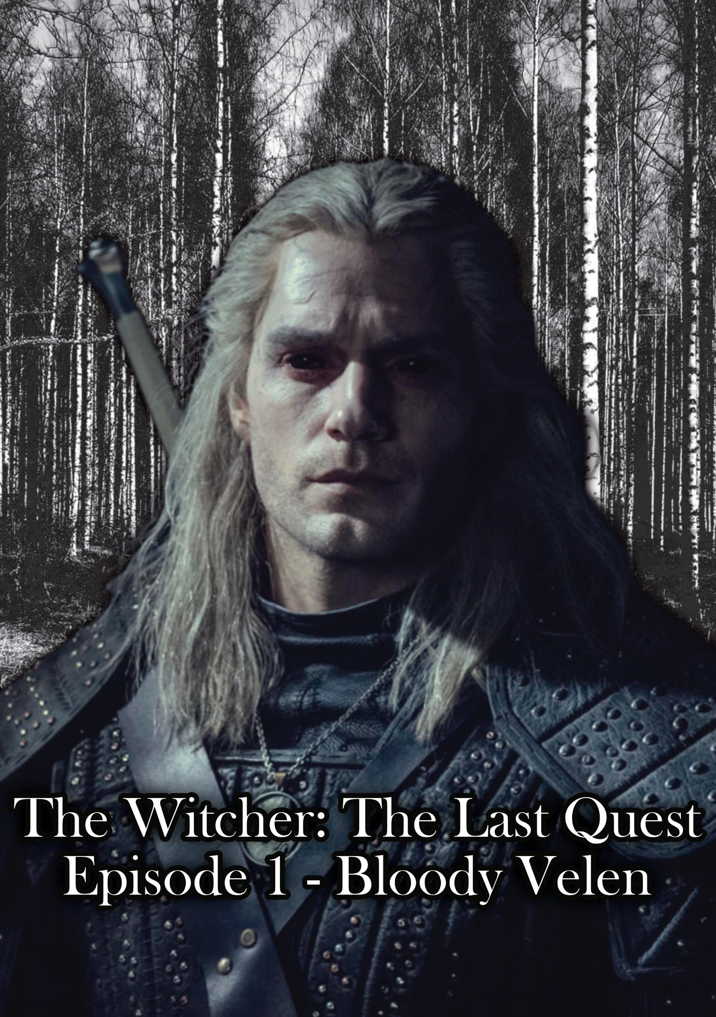

THE WITCHER: The Last Quest

A Song of Shadows

A synth drone shimmers on a dark black screen, it suddenly drops in frequency, resonating as a harsh distorted bass tone as the camera screams to life. A dark washed out dry color. We see a man on a horse from behind, a black tattered robe sways in the wind as it lightly rains. The synth drops out as the footsteps of the horse appear slow, tired, like a bell toll, as the camera rotates up, we see he’s on a road. A trader stands in the distance at his stand. He notices the man on the horse approaching and puts his hand on his blade. The horse stops in front of the stand, and the man gets off his force. He flicks a coin onto the store’s table and says:

“1.”

The trader looks down at the coin and raises an eyebrow; he then walks over and picks it up as he speaks:

“What brings you to Velen?”

He pauses for a second looking at the horse and then says:

“Alone?”

The man doesn’t respond.  
  
The trader puts a flagon of mead down and speaks:

“These are dangerous times…”

The man pauses and then says:

“I’m looking for someone…”

He takes a sip from the mead, and as he pulls the cup down the yellow glow of his eyes is noticed by the trader. He stumbles back.

“You’re… You’re a Mutant…”

The man doesn’t react.  
  
The trader spits on the ground and says:

“We don’t serve your kind here!”

The man takes his mead and silently gets on his horse. Nothing can be heard but the wind in the trees as the man sighs and says under his breath:

“Clearly you do…”

As he rides his horse down the road and takes a sip of the mead as we smash cut to:

***TITLE SCREEN:  
THE WITCHER – Episode 01: Bloody Velen***

We cut back the man, the wind whistling through the trees, the toll of the hooves of his horse ring through the landscape, echoing as they travel on the uneven stones of the road. A wagon ahead of him starts to approach, travelling in the opposite direction. The wheels screech as if they’re struggling to roll, the metal ripping sound tearing into the landscape. The man driving it doesn’t look up as the man watches him. We see intercut scenes of different elements of the road. A man’s head lies in the dirt. Crows fly off overhead. Drowners shuffle in the swamp like zombies. We see the man on his horse as he arrives to a tree. He looks up at the 5 men hanging from the branches like ornaments on a Christmas tree. He slides of his horse and as he approaches the environment goes black and white as the sound of the environment cuts and a low synth base rumbles, color bleeds through the landscape, red footsteps and lines as if someone was dragged appear in front of the man as he walks up to the tree, we see 2 red ghostly figures hang another red figure, the black, white and red environment fades, revealing an unidentifiable body being pecked at by the crows. We see the man’s face, his cheeks tighten and he says:

“Humanity… making itself extinct…”

He walks past the tree as we pan up to reveal a recent battleground just over the hill. Bodies lay still in the soil, birds picking at the remains, drowners feasting on the corpses. The man sits down and takes out his water; he takes a sip and then says:

“So, this is Velen now?”

We see a short intercut of the montage of the carnage, old broken war machines have men impaled on them, feasting animals and the litter of corpses. A drowner rips at the flesh of a body on the ground and looks around with blood dripping from its mouth. We smash cut to a close-up of the man’s face. He sighs and then says

“All things considered… It’s nicer than I remember it.”

That base synth comes in as we smash cut to a side shot of the man walking with his horse, through the field of feasting drowners. We see they notice him but he’s far enough away, so they don’t charge him. He’s about to exit the field and one appears from the ground below him, a water filled depression in the landscape. The man draws his blade, and the drowner jumps at him, in midair the blade slashes into the drowner through its collar bone, the silver sizzling against its flesh. The blade is stuck in its chest, and the man stumbles back slightly as it lands, deepening its own gutting. He regains his footing fighting the drowner’s attempts to swipe at him and slashes down with a tired yet powerful and forceful grunt. We see his face, now bloodied as he breathes heavily and regains his breath. He looks over at the Drowner, and it peels in half and splashes into the ground back into a puddle, its blood tainting the color of the water. The man walks towards his horse and says, “Come on Roach.” Pulling on the horses’ bindings lightly as it walks alongside him. We cut to the body on the ground, 3 drowners rise out of the ground around it, and start to feast on its body after they’ve passed. We see the man as he walks down the forest trail.   
  
A twig snaps harshly in the woods. The man’s face looks sideways, slowly, we see his eyes, tired, his face partially scarred. He slowly enters the dark swampy forest. He raises his sword as he walks through the trees as the tension and a slight tone rise in the background. He hears twigs breaking and rusting behind a large tree, he turns the corner raising his blade and sees a child playing with sticks. The young boy looks up and looks scared for just a second, the man puts away his blade sighing and speaks:

“What are you doing out here?”

The boy smiles and speaks:

“’ello mister!”

The man kneels and speaks:

“Where are your parents?”

The boy goes back to playing with his sticks as he says weirdly happily:

“Me parents died in the biting cold last year.”

The man pauses for a second and then says:

“It’s really not safe for you out here alone.”

The boy says

“Oh, I’m not alone mister, I’ve got me friends.”

The man looks around and there is nothing near them. He then adds:

“And they are where?”

The boy says:

“Me friends are right here with me.”

The man realizing, pauses for a second and says:

“Do you have a name?”

The boy smiles and says:

“Me name’s Tobin mister.”

Geralt smiles and puts his hand out and says:

“Come on Tobin. You shouldn’t be out here, it’s dangerous.”

The boy hesitates then takes his hand. They start to walk, and the boy says:

“I never seen eyes like yours mister, ‘ho are you?”

The man says:

“I’m a Witcher.”

The boy says:

“Is that like a man witch?”

The witcher smiles and says:

“No, I hunt monsters.”

They arrive at Roach and the witcher lifts the boy onto the horse and then says:

“If you sit quietly and don’t ask any more questions, I’ll buy you a loaf of bread when we get to the next town.”

The boy smiles and nods his head. The witcher walks to the front as he notices him stroking roach. He side-eyes roach and says under his breath…

“It’s just temporary.”

He pulls lightly on his bindings, and they start to move. Журавли sung by Mark Bernes starts to play, starts to transition to longer intercut scenes of the journey through the forest. Men sprawled across the road, mouths still open as if they’re still trying to scream, drowners rummaging through the remains unfazed by their presence, Geralts cloak licking the puddles of tainted water, glistening in the light of the sunset, tree branches ripped off their trunks, a man crushed by a tree lies forgotten, unidentifiable, the forest consuming the camera, dark, permanent twilight, a void screaming at them. It fades out as they exit the forest and see a large castle structure surrounded and flanked by levels of a village. Guards stand on either side of the road. Geralt and the boy start to walk towards them, and bandits ride out of the woods from the side, 2 on horseback, 3 running, the guards begin to fight the bandits off. Taking down one of their horses, the man falls off breaking his neck on a rock as he crashes to the ground. Two more bandits go down as more guards run to assist their compatriots. The second guard goes down; the bandits loot the bodies quickly trying to run away. We see Geralt watch as a bandit runs toward him. He turns to the boy and speaks:

“Close your eyes.”

The boy puts his face in his hands as the bandit runs past. Geralt draws his blade, slicing the bandit’s neck. For a second the bandit is unaware of what happened but quickly grabs his neck and drops what he stole. Geralt picks it up, now covered with blood and then says:

“It’s over, you can see again.”

The boy opens his eyes and looks down at the body, unfazed. He turns to Geralt and says:

“Mister, can you teach me how to use a sword?”

Geralt smiles and says:

“We’ll see.”

They continue to walk past the guards; Geralt drops the loot the bandit stole at one of their feet and says:

“For the family…”

He says after passing under his breath:

“I guess…”

They walk up a long wooden bridge and enter the town, people shuffle, avoiding him, some lock up their houses, others are too drunk, tired, or broken to care. They walk up to a Tavern and Geralt stops looking at the sign, he turns to the boy and says:

“Do you drink?”

The boy says:

“I don’t like mead.”

Geralt smiles and says:

“You’ll learn to.”

He picks him up off the horse and they enter the Tavern. The boy runs and sits at an empty table; Geralt walks up to the counter not showing his face to the tavern keep and speaks:

“1 Flagon of Mead…”

He looks over at the boy and sighs and then says:

“No, 2.”

The tavern keep raises an eyebrow and says:

“The boy likes mead?”

Geralt pauses and then says:

“No, they’re both for me.”

The tavern keep laughs and says:

“2 flagons of Mead, I’ll bring them over to you when they’re ready.”

Geralt places 5 coins on the bench and says:

“Thank you.”

He walks back over and sits with the boy. The boy is playing with some crudely made stick figures. Geralt notices a bruise on his arm and says nothing about it. The woman brings the mead over to them and says:

“You’re 1 Crown short mister.”

Geralt pulls out a small leather purse and says:

“3 Crowns? It was 1 down the road.”

The woman says:

“We got fees to pay here.”

Geralt sighs and places the crown on the table. The woman picks it up and walks away, Geralt starts to drink as the boy plays with his figures quietly. He finishes one and places it down with a solid, yet light thud. He then says:

“So, if you were alone in the woods, your parents are gone, where do you live now?”

The boy pauses and then says:

“I got a new mommy and daddy mister.”

Geralt says:

“And they are?”

The boy says:

“They’re nice, good people me thinks.”

Geralt sighs and says:

“Where are they? Not who are they…”

The boy says:

“Just down the road.”

Geralt says:

“So, you know your way home?”

The boy pauses looking down at his figures as he says:

“I don’t want to go home.”

Geralt looks confused, and then looks at the bruise again, he realizes and takes a breath. He then says:

“I’m going to meet the Baron, maybe he can help you find somewhere new to live.”

The boy says surprised:

“You’re meeting the bloody baron?”

Geralt says:

“That’s surprising?”

The boy pauses and says:

“He’s a bad man, and you’re a nice man.”

Geralt doesn’t say anything as he continues:

“The nice men that meet him, don’t return nice.”

Geralt looks down at his drink, he sighs, placing it down and then stands and says:

“Now I’m more interested to meet him.”

The boy stands up, and they exit the tavern. Geralt walks over to Roach who’s eating hay and says:

“Don’t run off again.”

Roach huffs at him as he walks off, the boy running through the streets with his stick figures as they walk up the streets, circling around to the top of the castle. They push open a wooden gate halfway up the hill and eventually arrive at the courtyard. A dwarf blacksmith can be seen working with metal near the main gate. Geralt walks up to the gate with the boy.

One guard is sleeping leaning against the wall with the helmet over his eyes. The other is sharpening his sword sitting down. Geral walks over to the awake man and says:

“I’m here to see the Baron.”

The guard doesn’t look up and says:

“The baron’s not receiving any visi’ors.”

Geralt says:

“He’ll see me.”

The guard laughs and looks up as he says:

“Who do you think-“

He realizes who’s in front of him and then says:

“Of course, I’ll let him know.”

The guard slides open a wooden door on the wall next to him and says to a man inside the castle:

“Get the commander, now.”

He turns back around and there’s a tense silence. Geralt speaks as he looks around:

“What’s rent around here these days?”

The man looks a little surprised and then says:

“Around 16 Crowns a fortnight, the bloody Black Claw charge 40 Florens.”

Geralt pauses and then smiles:

“I’m guessing there isn’t a local bank?”

The guard says:

“Yeah, so we ‘ave to go all the way to fucking Novigrad to get crown.”

Geralt continues smiling:

“And Novigrad bankers… what a disaster.”

The guard laughs and says:

“You don’t know the ‘alf of it, charged me 16% just to convert my crown last time.”

The gate opens and the commander walks out as he says:

“The Baron will see you.”

He notices the boy and then says:

“It’s best not to bring the child.”

Geralt walks over to him and whispers:

“He needs a new home; the current parents have… issues.”

The commander pauses and says:

“I’ll take him, find something by the end of the day. For now, he must stay here.”

Geral looks over at the boy and says:

“Can you stay here? This kind guard will watch you.”

The guard looks over and says:

“What?”

The commander and Geralt glare at him and the guard scratches his head and says:

“Yeah, alright I’ll watch the boy.”

The commander says indicated to Geralt:

“Perfect. Come with me.”

They walk into an open courtyard, a flower garden can be seen in the distance, next to a large manor estate. As they walk past the stables, they hear a punching sound inside and a harsh voice shouting:

“All of this can end when you give me a bloody name!”

A voice responds:

“I swear I don’t know-“

A punch cuts through his words. The commander notices that Geralt has paused listening to this. He walks up to him closer and says:

“Best not to think about it. The Baron doesn’t like to be… interrupted.”

Geralt looks at the man acknowledging silently, and they start to walk towards the manor. They enter a room inside, a desk is covered with empty bottles of alcohol, dirty glass, maps of the area, and letters with a knife stabbed through them. The commander says:

“The baron will be in shortly.”

He leaves and the door closes. A harsh base synth tone plays as the world goes black and white, fat round and red ghostly figures move through the room enacting different actions. Picking up a book, throwing a glass shouting, the fat figure hits a smaller red figure and a woman’s voice can be heard. We see Geralt’s jaw tightens watching this.   
  
We cut to the Baron walking out of the stables, the commander waiting for him outside. He's washing his hands with a dirty cloth and starts towards the manor. The commander starts:

“There’s a man waiting for you, I thought you should meet him.”

The Baron pauses and looks at him:

“I told you no guests.”

The commander gulps and nervously says:

“I kno- I know. He’s a Witcher.”

For a second the Baron doesn’t respond and then he smiles and says:

“Good, I need one.”

We cut back to the Witcher sitting now, watching the ghosts in the room, a young, small figure is sitting next to him, and we hear a woman’s voice:

“I’m just passing through I promise.”

The Baron’s voice responds:

“You can stay as long as you like, you need to regain your strength.”

We see Geralt’s face, watching the interaction, a little sad, ponderous, stern. Suddenly the door swings open, and the ghosts fade in seconds. The Baron speaks:

“Witcher! What brings you to our slice of hell?”

Geralt doesn’t respond for a second, then says:

“I’m looking for a girl, white ashen hair, passed through here recently.”

The Baron grabs a bottle of a clear white liquid and two glasses and sits down. He pours both glasses to the rim and says:

“There was a girl, but I’m not comfortable giving that information away to someone I don’t know.”

Geralt pauses and then says, a little ironically:

“How political of you.”

The Baron’s eyes light up and he says:

“Ah… you’re the one she spoke of.”

Geralt says:

“Can you help me or not?”

The baron leans back and says:

“Perhaps, but I offer you a trade instead. You help me, I’ll help you.”

Geralt pauses and then says:

“What kind of help?”

The Baron’s face changes darker, more solemn:

“My wife and daughter are missing, one night they just vanished, and I have no idea where they are.”

Geralt says:

“Women don’t just vanish… they leave... or die.”

The Baron’s face goes flat and he says:

“Just find them, and I’ll tell you what I know.”

Geralt pauses silently for a second. He reaches over to his drink and picks it up and says:

“I’ll need more information.”

The Baron says:

“Later, later. Tell me a story, I love a good story.”

Geralt takes a sip of his drink, takes a breath and with a small smile says:

“Do you play Gwent?”

Smash cut to a quote fading on screen:  
  
“In loving memory  
  
Of all those lost to war…  
  
No matter how important.”

We then cut credits with a custom original soundtrack or one of the 3 options below would fit:

1. Folk Blues Vibes:

This tonally ends the episode on a melancholier note, think:

* Hurt by 9 Inch Nails
* Goodnight Moon by Shivaree
* The World We Knew by Frank Sinatra (This could genuinely work on its own)

Goal: A big, full, but pain riddled song. A mirror to Geralt’s soul and the world he’s navigating. That is the Witcher in sonic form.

1. Country “travelling” music:

This tonally ends the episode on more of a “he’s still out there” note, think:

* Literally anything The Devil Makes Three (Ten Feet Tall, Old Number Seven, The Plank, Graveyard), alcoholic vibes feel me?

1. Coral Vibes:

Basically, Hoist the Colours but adapted for this universe, dark, solitary, coral melodies cut through the soul, think:

* Dies Irae
* Mozart – Requiem K.636 – Lacrimosa
* Vois sur ton chermin (the original)
* Even the HALO theme

Any of these options work tonally, my favorite personally is the first, but either one of the three works for the emotional impact of the universe. It also would be interesting to experiment and back develop a folk version of a glue song that mimics old European folk but still feels alien and fantasy. Choral is more direct “This is a mirror for history” the others take modern themes and work them into that mirror potentially making them more relatable.  
  
Perhaps even blending the three, you’d get: the epic, choral, timeless call of the world; the melancholy of Geralt’s soul responding to the void; and the wandering, travelling feel that reminds us the story isn’t over that there’s so much more to come.

*Author’s Note:*

*The characters and world of The Witcher belong to Andrzej Sapkowski and CD Projekt Red. This script, the dialogue, story flow, and narrative choices, is entirely my original work and is protected under Australian copyright law (registration pending). It is not intended for commercial use. Any use of this material without permission is prohibited, though reaction videos, breakdowns, and discussions are welcome and permitted in the spirit of collaboration. Additionally, artwork based on this is allowed, however I cannot guarantee, authorize or otherwise state that the shareholders will feel the same.*

Thank you for reading.

END OF EPISODE.